User Manual MANUAL

Portable Thermal Printer

BT-II SERIES

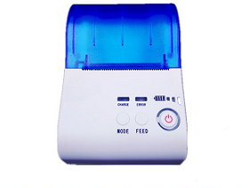

Content
Precautions 3
Chapter 1 Product introduce 7
1.1 Printer exterior 7
1.2 Accessory 7
1.2.1 Standard accessories 7
1.2.2 Options accessories 8
Chapter2 Function characters 8
2.1 Specifications 8
2.2 Other specifications 9
Chapter 3 Using method 10
3.1 Prepare before using 10
3.1.1 Li-ion battery installation 10
3.1.2 Paper loading 10
3.2 Basic function using 11
3.2.1 Turn on 11
3.2.2 Turn off 11
3.2.3 Inspect itself 11
3.2.4 Paper feeding 12
3.2.5 Charging 12
3.3 Print connection and printing 12
3.3.1 Serial connection 12
3.3.2 Bluetooth 13
3.3.3 Matched pair 14
3.4 LED Indicator and buzzer definition 15
Chapter 4 Other information 15
4.1 Printer technical manual 15
4.2 Preprinted black mark specification 15
4.3 Auto dormancy/automatic awaken, automatic turnoff 16

Precautions
◆ Safety Precautions
In using the present appliance, please keep the following safety regulations in order to prevent any hazard or material damage.

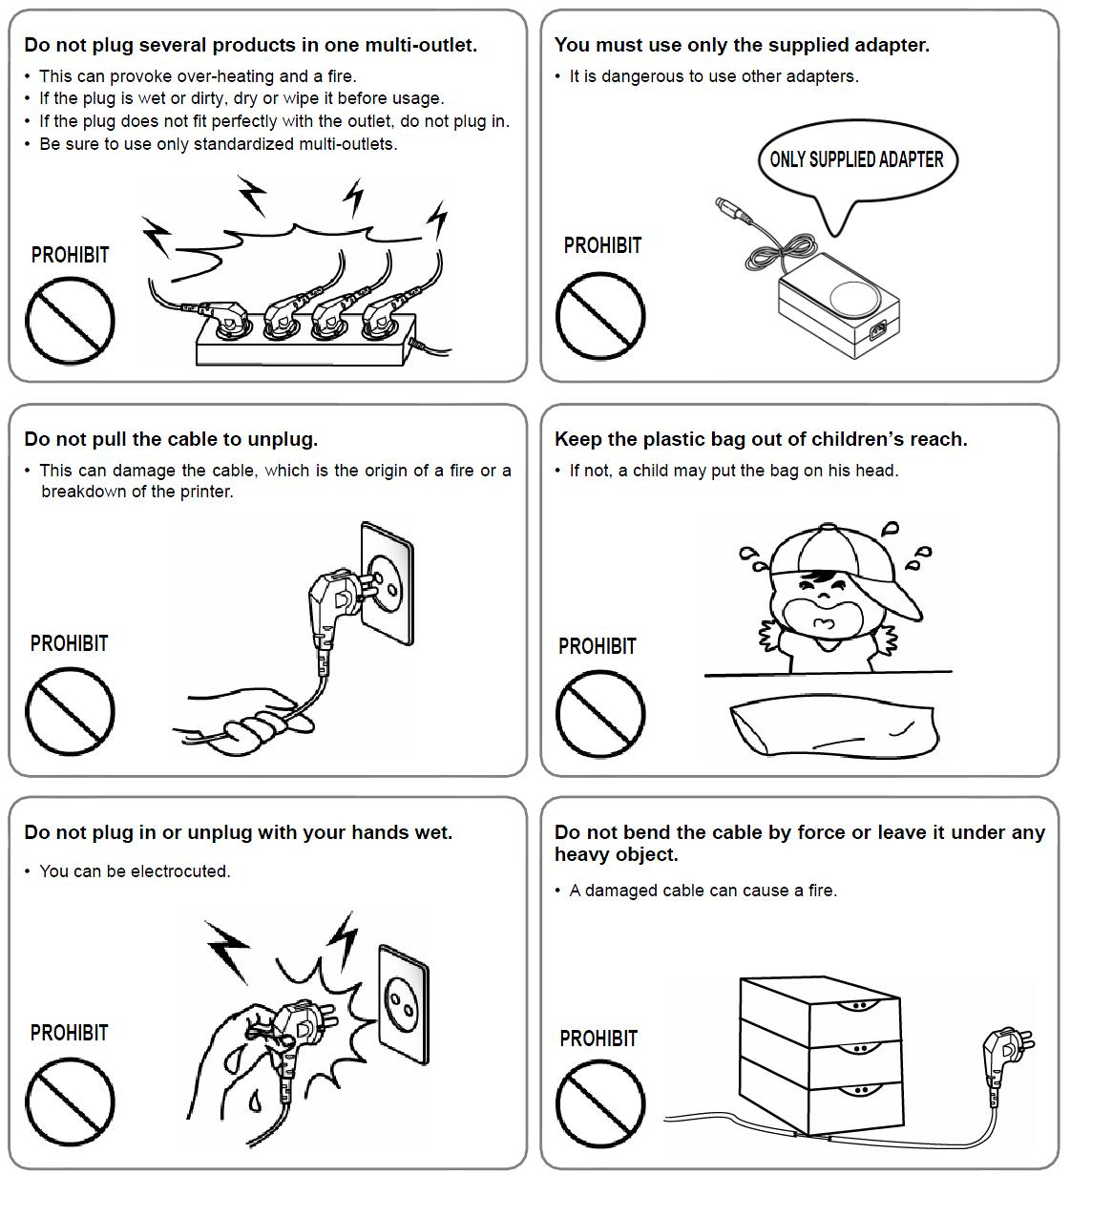

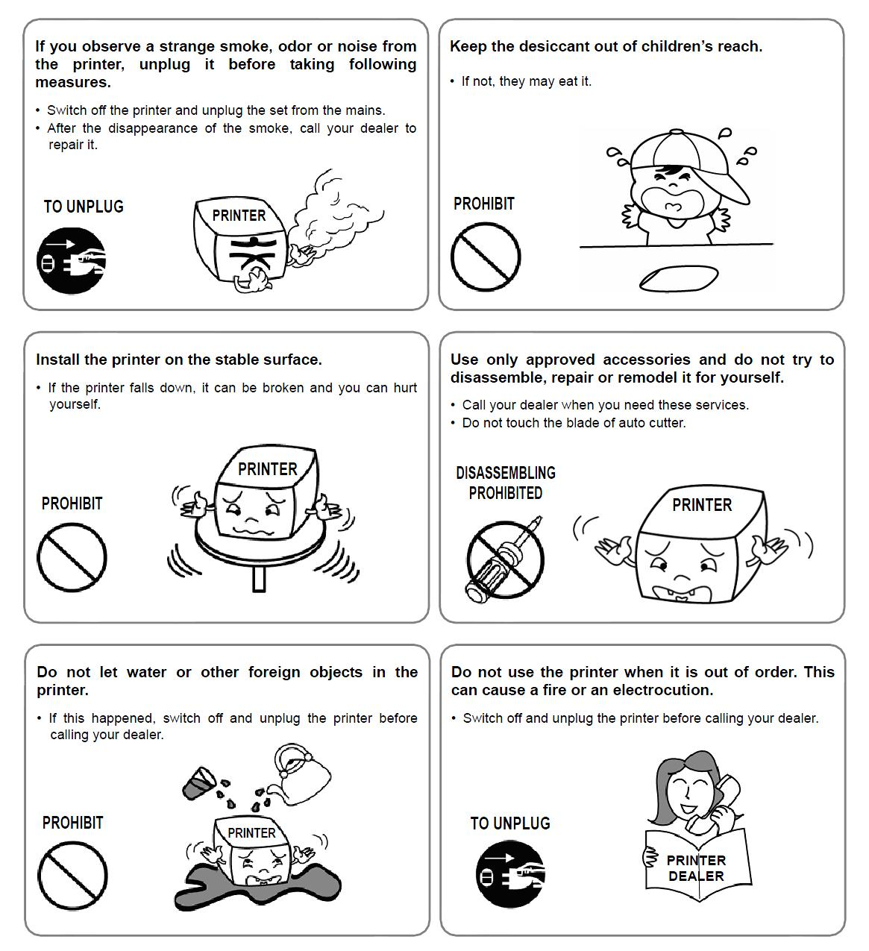
◆ Operation Precautions
Be sure not to print continuously over 1meter, otherwise may cause damage to the printer head.
Water or other liquid should not spill into the printer, also the printer should not be appeared in the rain, or else may cause printer damage.
Please do not open the paper case cover when printing; otherwise the printer may work improperly.
If print with serial interface, should not unplug the interface cable in the course of printing, or else some printing data may be lost.
When print with Bluetooth interface, the communication distance should be within10 meters, otherwise the printer doesn’t print or prints rubbish codes.
Too high(50℃) or too low(-10℃)temperature and too high(80%) or too low (20%) relative humidity both effect the quality.
The print paper in poor quality or stored for too long time also may reduce the print quality even damage the printer.
In the black mark detecting mode, the printer requires that the preprinted black mark is accordant with the black mark specifications (details please refer to 4.2); otherwise the black mark can not be detected correctly.
Be sure to use up the power of the battery before charge it, as it can ensure the using life of the battery.
◆ Storage Precautions
The printer should be placed in such an environment that the temperature is between -20℃ and 70℃, and the relative humidity is between 5% and 95%.
If the printer will be stored for a long time, please be sure to take out the battery, otherwise may damage the battery and printer.
Normal thermal paper can’t be kept too long time. If you need to keep the receipt for a long period, please choose long term effective thermal paper.
The paper should be keep away from high temperature environment and point-blank sunshine.
◆ Battery Safety Precautions.
Be sure to carefully read the user manual before using the produce.
Ignore the following instructions may cause battery overheating, fire, explosion, damage and/or performance, and reduced product life.
- Risk of explosion if battery is replaced by an incorrect type.
- Dispose of used batteries according to the instructions.
- Do not allow water, sea water from entering or leaking into the battery inside. If the batteries internal safety device burn, when changing it, it may produce any abnormal current and/or voltage, and cause any abnormal chemical reaction, then may cause the battery overheating, fire and/or explosion.
- Do not use or place the battery nearby the stove or other high temperature places. Excessive heats maybe damage the resin shell and/or the insulation materials, and then the battery may be caused overheating, burning and/or explosion.
- When charging, use a specified charger. Other conditions (high temperature, high pressure/high current, using the modified battery charger, etc) excludes here may result in over-charging the battery and abnormal current and/or voltage, cause abnormal chemical reaction, and may cause the battery overheat, light and/or explosion.
- Battery clearly marks with positive and negative. When connect the battery with the charger and/or printer, be sure to verify the correct battery orientation. Reverse insertion will cause the reverse charging and may cause abnormal chemical reaction, and then may cause the battery overheat, ignite, and/or explosion.
- Do not make the battery contact with the power outlet and/or car cigarette lighter socket. This may cause high pressure and excessive current, and lead to the battery overheat, burning and/or explosion.
- Do not heat the battery or put the battery into fire. This may melt insulation material and/or damage safety devices or safety equipment, then ignite electrolytic solution, and cause the battery overheat, burning and/or explosion.
- Do not use the battery with contrary (+) and (-) Location. In the charging process, this will cause the reverse charging and may cause abnormal chemical reaction. During use, may appear unpredictable current exception, and cause the battery overheat, ignite, and/or explosion.
- Do not make the battery (+) and (-) contact with any metal. Also, do not carry along or store batteries with metal objects, such as necklaces, hair clips and so on. Battery internal short circuit may cause excessive current, and lead to the battery overheats, ignite, and/or explosion and the adjacent metal objects (necklaces, hairpins, etc.) may be overheating.
- Do not throw or heavy attack the battery. If internal safety device of the batteries burn, the battery charging may cause any abnormal current and/or voltage, and abnormal chemical reaction, and lead to the battery overheat, ignite, and/or explosion.

Chapter 1 Product introduce

1.1 Printer exterior
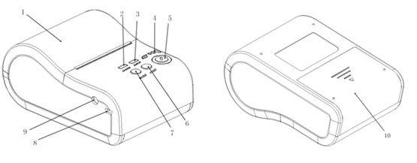
- Paper cover
- CHARGE indicator light
- ERROR indicator light
- Batt low indicator light
- Power button
- paper feed
- Self-checking buttons
- Mini USB port
- Power port
- Battery Cover

Note: The status indicator and charging indicator light separately be set in above of the two keys. Using red and blue to show different mean.

1.2 Accessory

1.2.1 Standard accessories
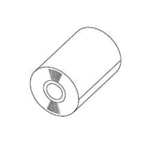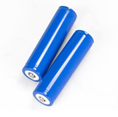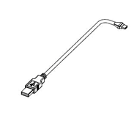
Paper Roll Battery USB Interface Cable
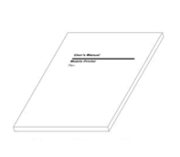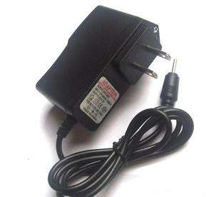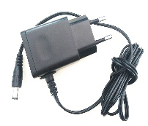
User Manual Power Adapter

1.2.2 Options accessories
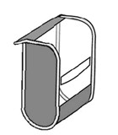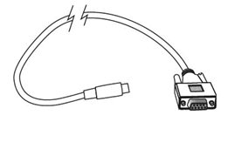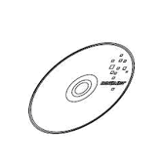
CD serial port cable CD

Chapter2 Function characters

2.1 Specifications
Model | BT-II/IR | BT-II/BT | BT-II/WIFI(Developing)
Printing method | Line thermal printer
Printing speed | 50~80mm/s
Dot pitch | 8dots/mm, 384 dots/line
Printing width | 48mm
Paper width | 57.5±0.5mm
Paper roll outer diameter | 50mm (Max.)
Paper roll inner diameter | 13mm(Min.)
Paper thickness | 60-80um
Overall dimension(WxDxH): | 124*85*57mm
Weight ( g) | 210(non- including the paper roll)
Printing characters | ANK: 8x16,9X17, 9x24,12x24 GBK:24x24
Characters/line | ANK:48, 42, 32 GBK:24, 16
Life cycle time | 50km(printing density under 12.5%)/100 million pulses
Barcode type | 1D: UPC-A,UPC-E,EAN-13,EAN-8,CODE39,CODE93,  CODE128,CODEBAR,ITF25
Barcode type | 2D: QR CODE, PDF417
interface | Bluetooth V2.1 CLASS (V4.0 Developing) CLASS ,RS232,USB |  | RS232, USB
Power | 1500mAh 7.4V rechargeable Lithium battery
Recharge adapter | Stand by recharging / AC adapter
Black mark test | Supported
Paper feeding | Easy paper loading
Paper cut | By hands
commands | ESC/POS compatible with order sets
operate setting | Temperature -10°C~50°C ; Humidity 20%~85%
Recharge Setting | Temperature 5°C~40°C; Humidity 20%~85%
Storage Setting | Temperature -20°C~70°C ; Humidity 5%~95%
Standard accessories | leather coat, li-ion battery, AC adapter, USB interface cable, Long-term preservable paper, user manual
Optional accessories | Serial interface cable/CD/Car charger

2.2 Other specifications
- Paper feeding method: clamshell feeding, please refer to the chapter 3.1.2
- Mark position: black mark position, please refer to the chapter 4.2
- Paper sensor: LED indicator flashes when come to paper end meanwhile alarm.
- Printing control indication: ESC/POS compatible with order set
- Power supply:1500 mAh rechargeable Li-ion battery
- Power alarm: indicator flashes when printer will run out of power and give out two short hoots. When running out of power, it will give out interval hoot to indicate charging.
- Battery full charge time: 2 to 4 hours.
- Battery duration: under 15% print density, at least 100 to 200 meters, under 25% print density, at least 100 meters, the standby time is over 15 days.

Chapter 3 Using method

3.1 Prepare before using

3.1.1 Li-ion battery installation
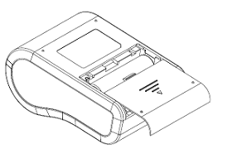
1) Refer to the picture, put the battery in the battery slot, and please pay attention to the correct positive and negative.
2) Close the battery case.

3.1.2 Paper loading
Top cover
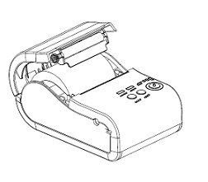
Use two fingers to press this place and open the top cover
Rubber Roller
Thermal paper roller
Operation methods:
1) Use two fingers to press the place showed in the above picture and open the top cover.
2) Put the paper roll into the paper case, pay attention to the direction of paper. If loaded reversely, it won’t print.
3) Pull paper out of paper case.
4) Make sure paper in the center then closed top cover.

3.2 Basic function using

3.2.1 Turn on
Under the close state, Press  [POWER] button 2 seconds, the printer enters to the working state, the power indicator light (Red).
NOTE: in cash the printer function indicator light(Blue) flash and with paper, it show the power will to be exhaust, if continue to use, please change one new battery or charging power. The charging method, please refer to chapter 3.2.3

3.2.2 Turn off
Opening state, press [POWER] button 2 seconds, the printer will be closed, all the indicator light will be off.

3.2.3 Inspect itself
The user can inspect the printer by themselves after getting the printer. To check the current state and setting.
Inspect method: turn-off. Hold  [FEED] button, and then press [POWER] button the printer will print out the inspect page, the inspect page including the current state, setting, example of printer.

3.2.4 Paper feeding
Under the usual working state, press [FEED] button, start to feed paper, and will stop till 250mm.
If the paper has dark mark approved by this printer, when print to the dark mark, the printer will stop feed paper. If the feed length is setup as 0, it will be not affected by the dark mark.

3.2.5 Charging
When the power of batter to be exhausted, the function indicator shows (Blue) and flash, at the same time, the printer will give an alarm, at the comment, the user should charge the power.
The charging method: connect to the power 100-240VAC,50/60HZ,during the charging , the charging indicator light show blue and flash till finished, at the same time , the charging indicator light have been lighting
During charging, the user can usually use the printer.

3.3 Print connection and printing

3.3.1 Serial connection
The printer have one DB-9 serial port cable as option (one port connect to the printer, the other connect to MINI DIN plug)

3.3.2 Bluetooth
BT-II/BT support wireless data transmission interface, meet Bluetooth 1.1 regulations, power class 2.
BT-II/BT is only sub-device, and user need to drive the printer by Bluetooth host devices (such as PDA, mobile phone, laptop).and other Bluetooth sub-device (such as bluetooth earphone) can’t drive the printer to print by Bluetooth.
Using method:
1. Through the Bluetooth tray (or on the control board), right click the Bluetooth logo, choose” Add Bluetooth equipment
2. after some time, to show find out the new equipment “BT-II”
3. Choose “next step”, input the password”0000” in the third option” input the password” till to the finished
4. After finished, the system will show two serial port be added, general speaking, one is output port, the anther is input port.
5. Use super terminal to open” output port “, the baud rate of device is 9600, open the port.
6. Choice menus” file->attribute”, choose setting page, click the button” ASCII setting code” ,choose and tick the top two selection.
7. Click on the third button in the toolbar "call"
8 At the moment, Can enter any words, and then print it via Bluetooth printer
Note: Above 1-4 points as printer setting, 4-8 points as testing reference.

3.3.3 Matched pair
Before printing, BT－II/BT need to pair with the host devices that drives the mobile thermal printer. Pairing process is originated by the host devices.
Usual Pairing processes as follow:
1. Turn on the printer
2. The host device search exterior Bluetooth device
3. If there are some exterior Bluetooth devices, please select “BT-II”
4. Enter password “0000”.
5. Finish pairing.
Detailed pairing methods, please refer to the Bluetooth function introduction of the host devices
When pairing, mobile thermal printer BT-IImust be turn on.
Note: when pairing, do not turn on many printers at the same time, otherwise it can’t judge which one succeeds in pairing.
After finished pairing, other the host device (upper machine) still can pair with this mobile thermal printer. One printer can be most allowed to pair with 8 units upper machines (the host devices) . If the ninth device will be paired with the printer, the earliest ones will be deleted from printer paring list automatically. If this earliest device will be allowed to drive the printer again, it need to pair with the printer again.

3.4 LED Indicator and buzzer definition
BT-II has one buzzer and two LED indicators to indicate the printer status. The LED indicators indicate current status and buzzer indicates the changes of status.
Status | Bluetooth | CHARGE indicator |  | ERROR indicator |  | Buzzer
Status | Bluetooth | Blue | Red | Blue | Green | Buzzer
Power on |  |  | On |  |  | Rings once
Standby | No |  | flash
Standby | Yes | On
Charge | No |  | On |  | Flash and bright when full power | Rings once when full power
Charge | Yes | On |  |  | Flash and bright when full power | Rings once when full power
Out of paper | No |  | On | flash |  | rings three times every two seconds
Out of paper | Yes | On |  | flash |  | rings three times every two seconds
Power off |  |  |  |  | Bright when charging | Rings twice

Chapter 4 Other information

4.1 Printer technical manual
BT-II portable thermal printer technical manual can be provided by the supplier.

4.2 Preprinted black mark specification
If user wants to locate receipt by detecting preprinted black mark, shall accord to the following specification for the black mark. Otherwise it may cause printer can’t recognize the black mark.
Printing position: black mark shall preprint at the left side of receipt.
Width rang：≥7mm
Height：4mm≤height≤6mm
Reflection rate to IR：<10% （reflection rate to the black mark on paper >65% ）
Hps：Hps indicates the distance from down edge of detecting mark from beginning line.
0mm≤Hps≤1mm
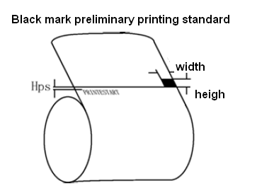

4.3 Auto dormancy/automatic awaken, automatic turnoff
In order to save energy, prolong the using time, BT-II printer adopts the advanced automatic dormancy, automatic awaken technology.
After turning on the Printer, if without any data sent to the printer by the host within two minute, and without pressing any buttons, the printer will be entering to the dormancy mode and the state indicator light (RED) will be in a state of slow flash .
After dormancy, the power consumption greatly reduced, and it will not affect the using. When receiving any printing data, the printer will be awaken automatically, without any other manual intervention.
After 2 hours, the printer does not receive any data, the printer will automatically turn off, and you should start it by manual.

